**EXPERIMENT 7**

**Aim:** To explore two graphs and view their arff file and apply an algorithm on them.

**Theory:**

We will use weather.arff and weather.nominal.arff files for the following experiment and use a classification algorithm on them.

Steps for exploring a graph:

1. Open Weka
2. Go to Applications then Explorer
3. In Pre-processor click on ‘open file’
4. Set path to ‘C:\Program Files\Weka-3-8-4\data’ then select the file you want to view the graph for
5. Click on ‘Visualize All’

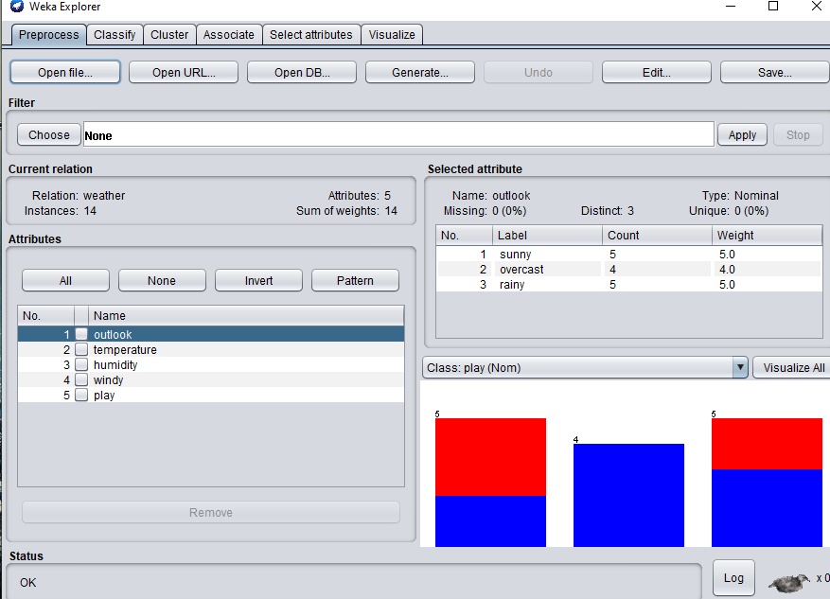

Fig: weather.arff file in Weka

**Output: Graph Visualization of two files:**

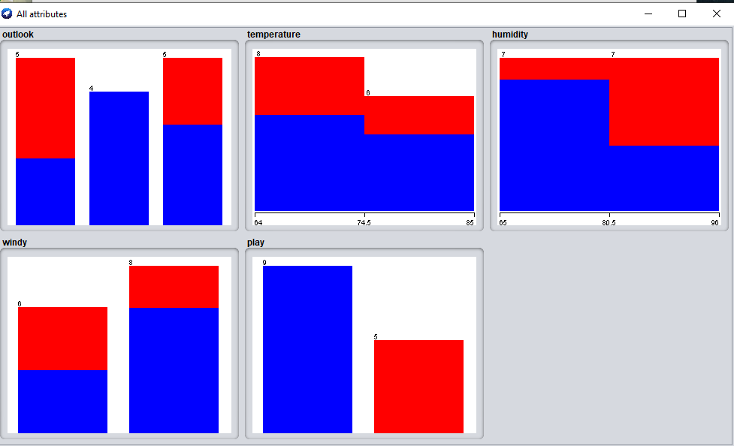 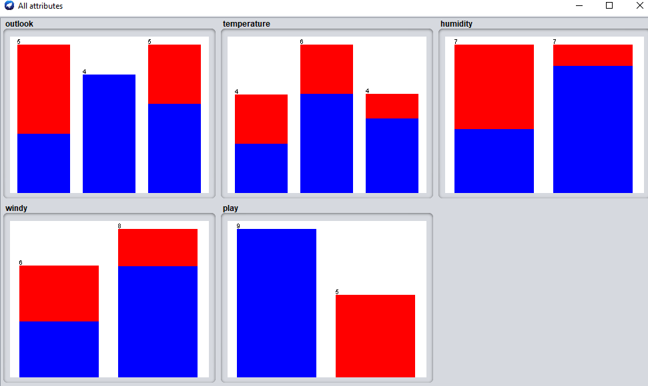

Fig: Graph for weather.arff Fig: Graph for weather.nominal.arff

**Steps** for viewing the arff file’s database:

1. Go to Tools and click on Arff Viewer
2. Go to Files and Open the file you want to view from the data folder
3. Choose weather.arff & weather.nominal.arff

**Output: Database of two arff files:**

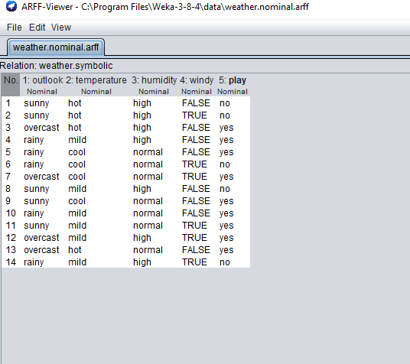 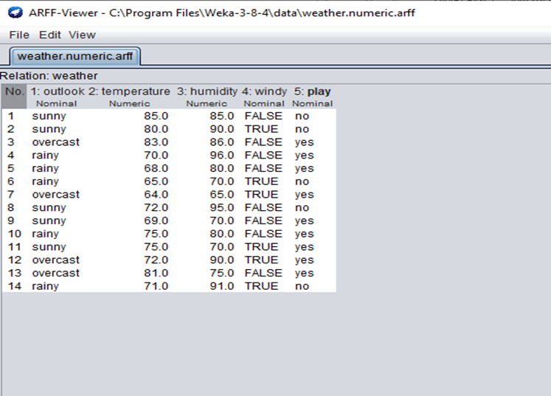

Fig: Database View of weather.arff Fig: Database View of weather.nominal.arff

**Steps** for applying an algorithm to the arff file:

1. Go to Classify
2. Choose OneR-B6 Algorithm and click Start to apply it
3. Right-click on the result list.
4. Click on Visualize Cost Curve (yes)

**Output: Classifier Output of two arff files:**

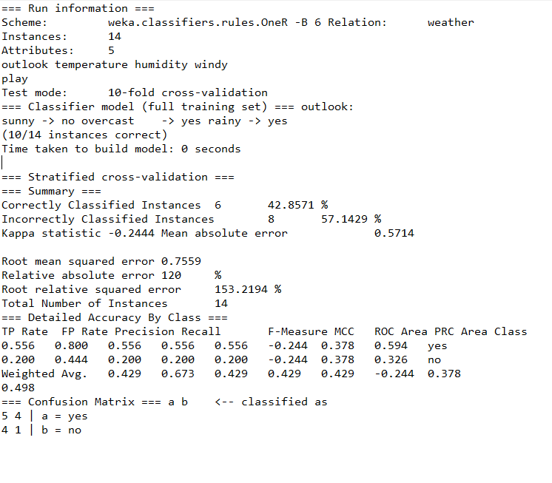

Classifier Output of weather.arff

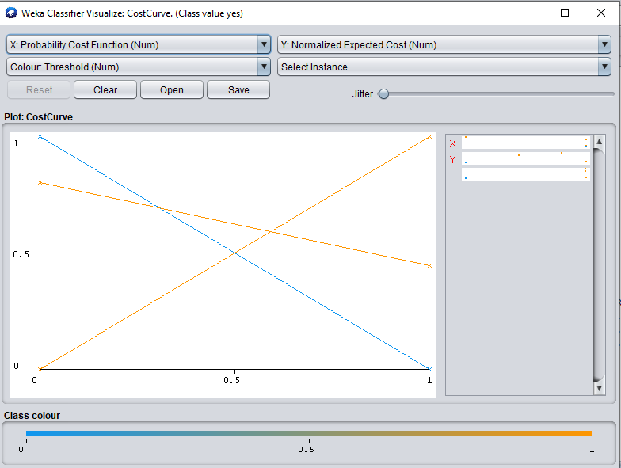

Fig: Cost Curve of weather.arff

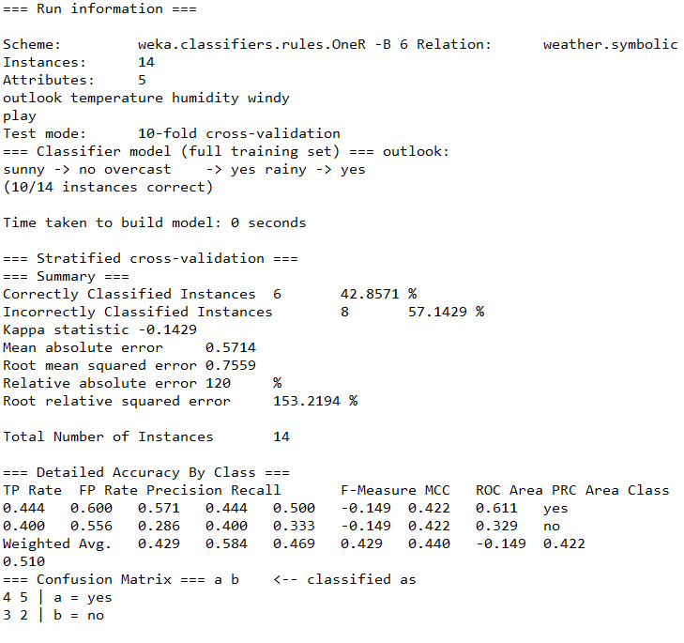

Classifier Output of weather.nominal.arff

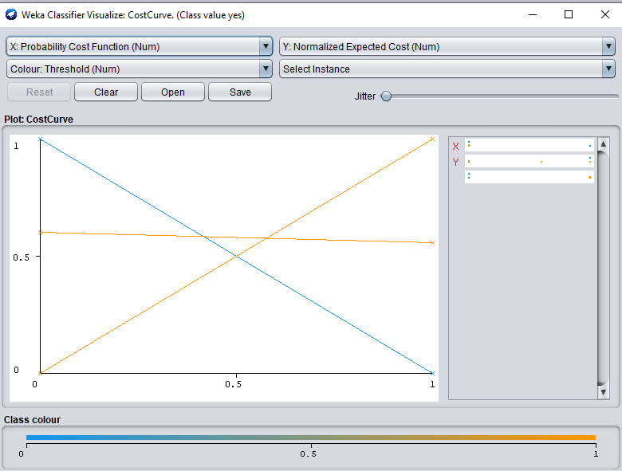

Fig: Cost Curve of weather.nominal.arff